CANOPY WITH FIXED ROOF

Manufacturer
RENSON Outdoor nv, Polydore Rensonstraat 8, 9770 Kruisem – Belgium
Tel. +32(0)56 30 30 00, info@renson.be, www.renson-outdoor.com

(texts in red may be removed according to your choice)

Description
Algarve® Canvas is an aluminium patio canopy with a horizontal roof, featuring an upper roof of profiled sheet steel and an aesthetic ceiling of fibreglass fabric stretched tight. The canopy is placed freestanding or mounted on a façade and is supported by vertical columns with concealed screws.

Dimensions
Span: Min. 800 mm
Max. 4500 mm
Pivot: Min. 895 mm
Max. 6055 mm
Free passage height: Max. 2800 mm
Total height: Free passage height + 230 mm
Coupled:
2 roof elements are coupled together via the pivot side in order to achieve a longer span side.
No extra column has to be placed between both roof elements.
Span per roof element: Min. 1500 mm
Max. 4500 mm
Span (sum of 2 roof elements) Min. 3000 mm
Max. 6000 mm
For information:
The span side corresponds with the width of the sheet steel
The pivot side is the side along which the various sheet steel elements are placed

System version

Type of installation
- Freestanding:
  - Freestanding, 4 columns
  - Self-supporting structure
- Façade mounting:
  - With one or 2 sides placed against a supporting construction / structure behind
  - 1 column (2 sides against the façade)
  - 2 columns (1 side against the façade)

Frame:
- Sturdy frame of extruded aluminium profiles
- Connection of adjacent frame profiles with aluminium corner cap, in the same surface as the profiles, painted in the colour of the supporting structure
- Each frame profile features mounting brackets in order to attach the stretch ceiling and upper roof
- Height: 230 mm
- Slope: 0°

Upper roof:
- Profiled aluminium sheet steel, featuring on the underside an anti-condensation layer to prevent drops of condensation from falling onto the underlying stretch ceiling.
- The upper roof is attached to the upper frame via mounting brackets.

Ceiling:
- The fixed roof is finished on the underside with a horizontal fibreglass fabric that is stretched tight using canvas tensioning profiles.
- The fabric is attached all round using zips in a canvas tensioning profile and attached on the mounting brackets on the upper frame.
- The canvas tensioning profiles can be pulled closer against the frame, resulting in the ceiling canvas being brought to the right tension and having a taut appearance.

Columns:
- Depending on the type of installation, 1, 2 or 4 columns are used
- Made from square aluminium profiles with a cross-section of 110 x 110 mm.
- The columns are attached below the mounting feet and at the top to the frame using screw channels in the column.
- The screw channels are covered with aluminium profiles that are painted in the colour of the column.

Mounting feet:
4 types:
- Visible mounting feet with visible floor plate
- Concealed mounting foot
- Reinforced visible mounting feet with visible floor plate and lengthened core
- Reinforced concealed mounting foot with lengthened core

Water drainage:
- The upper roof (sheet steel) is below a slope of 20 mm. Water runs through a perforated profile on the side from the upper roof to the gutter that is integrated in the profiles of the upper framework and runs around the entire canopy.
- Each column can function as a water downpipe. In the corner point of the upper frame there is a hole that ends in a PVC discharge pipe Ø50mm that has been integrated and concealed in the column.
- Along each side of each pivot side there is a hole in the gutter of Ø50 mm for the water drainage. In the hole there is a discharge pot that acts as a leaf trap and leads into the column.
- Water drainage from the column: Below the column there is an opening for discharging rainwater from the column.
Water drainage below the ground: below the column the drainage pipe is connected with an underground drainage pipe.

Colour:
All visible aluminium profiles are finished in a textured coating, RAL colour of your choice (60 – 80 micron)

Assembly:
All fixations (e.g. screws) are carried out in stainless steel and are concealed after installation.

Power and cables:
The electric cables are completely invisible and integrated in the canopy.

Technical properties

Maximum weight of snow (kg/m²):
According to dimensions
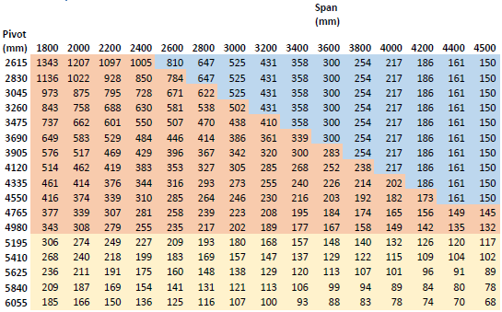

Wind resistant up to:
120 km/hour

Water drainage and rain rate:
The patio canopy can accommodate a rain flow rate that corresponds with a rain shower of intensity 0.04 l/s/m² to 0.05 l/s/m² lasting a max. of 7 minutes. This type of rainfall occurs every 2 years. (cf. Belgian rain statistics: NBN B 52-011)

Guarantee
- 5-year warranty on the structure (all defects that may arise during normal domestic use and with regular maintenance)
- 5-year warranty on Somfy® automation
- 10-Year warranty on the colourfastness of the paintwork of the aluminium profiles.
- 5-year warranty on sheen (paintwork):

Options

Up/Down LED lighting:
Integrated LED lighting on the inside of the framework over the compete length fitted with upward and downward lighting.
- Up:
  - Warm white light 120 LEDs/M | +/-2800K | 550-680 lumen/m
  - Pure white light 120 LEDs/m | +/5000K | 550-680 lumen/m
- Down:
  - Warm white light 120 LEDs/M | +/-2800K | 550-680 lumen/m
  - Pure white light 120 LEDs/m | +/5000K | 550-680 lumen/m
  - RGB 60 LEDs/m | 550-700 lumen/m

Standards
This product has been made, meets and/or has been tested in accordance with the standard: EN 13561

